SAIGAN Pvt. Ltd.
(PVC PIPES SUPPLIER)

Proposed by
Ganesh Kumar Chimakurthi
M.Sc. in Data Analytics
X16130961
Abstract:
Saigan Pvt. Ltd. is PVC pipelines suppliers which produces quality pipes to the customer with good number of customers. Now, it is using salesforce to expand its business and its profits. Implementing salesforce in company to store huge records and it also makes people easy to order pipes and by providing convenience to customer to not wait in store for hours. Rather, they can simply order those pipes trough online.

Salesforce:
Salesforce is a platform which provides best customer relation management which brings all the customer related data together from all the fields such as sales, Orders, Marketing etc. Since, Customer relation management is main promoter in getting success of company, it can be achieved by using salesforce where we can get entire vision of business which helps in understanding the company in better way. Salesforce can be easily implemented in business due to its simplicity, it does not require any installation software.

The Implementation of salesforce in our company has been done by creating account in salesforce. In salesforce, I created multiple tabs such . It undergoes multiple process such as
- Architecture Description
- Process control features Description
- Description about integration and user interfaces
- Reports
- How datasets were built
- Steps taken while building a system
- How system is used
- Benefits

1.Architecture:
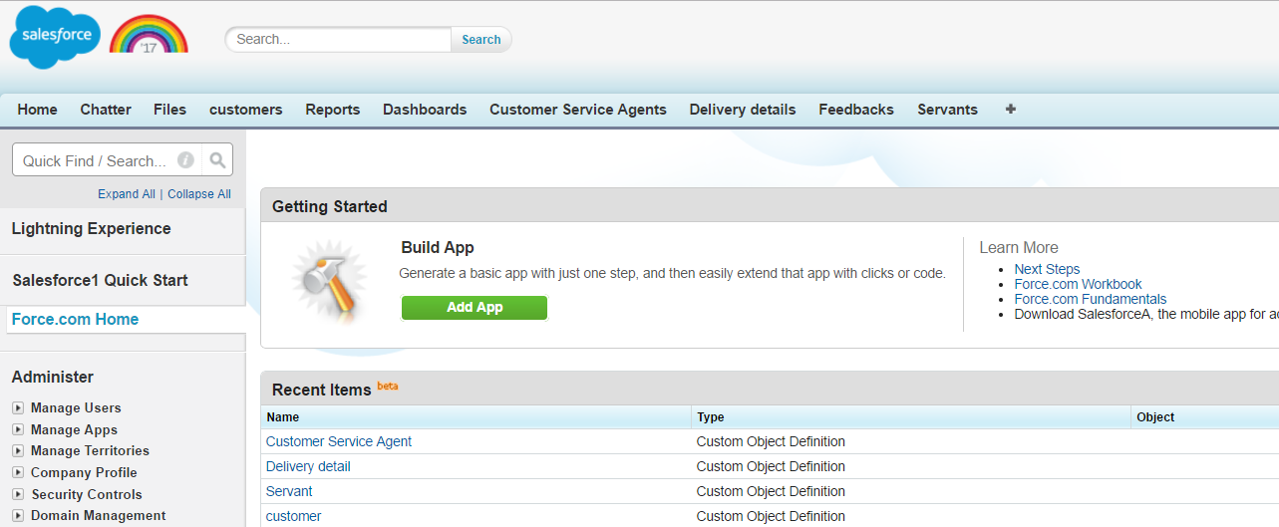
The architecture contains multiple tabs such as customer, customer service agent, Delivery Details, Servants and Feedbacks.
Customers:
It stores all the customer’s information coming to Saigen Pvt. Ltd. such as Name, gender, address, Mobile no and email of customer.
Customer Service Agent:
Customer Service Agent is employee who serves the customer in organization. This tab consists of Employee id, Mobile no, Name, Address and Gender of employee.
Delivery Details:
It contains details of Bill price of customer, delivery date and Address of customers where products have to be delivered.
Servants:
This tab includes the servants details such Servant name, Servant mobile no, servant id, vehicle id (which is using by particular servant).

Feedbacks:
Feedback taken from customers is stored in this tab. It will be stored in form of Customer id, and score given by that customer.

2.Process Control:
The process flows from customer where customer triggers the process. Here, Customer enters in to website and requests the order through online. Customer service agent receives the request in web case and he will notify the customer regarding their delivery. Then, customer service agent will notify the servant about the details of customer and servant will deliver the order to the customer. Finally servant takes feedback from the customer and updates in portal.

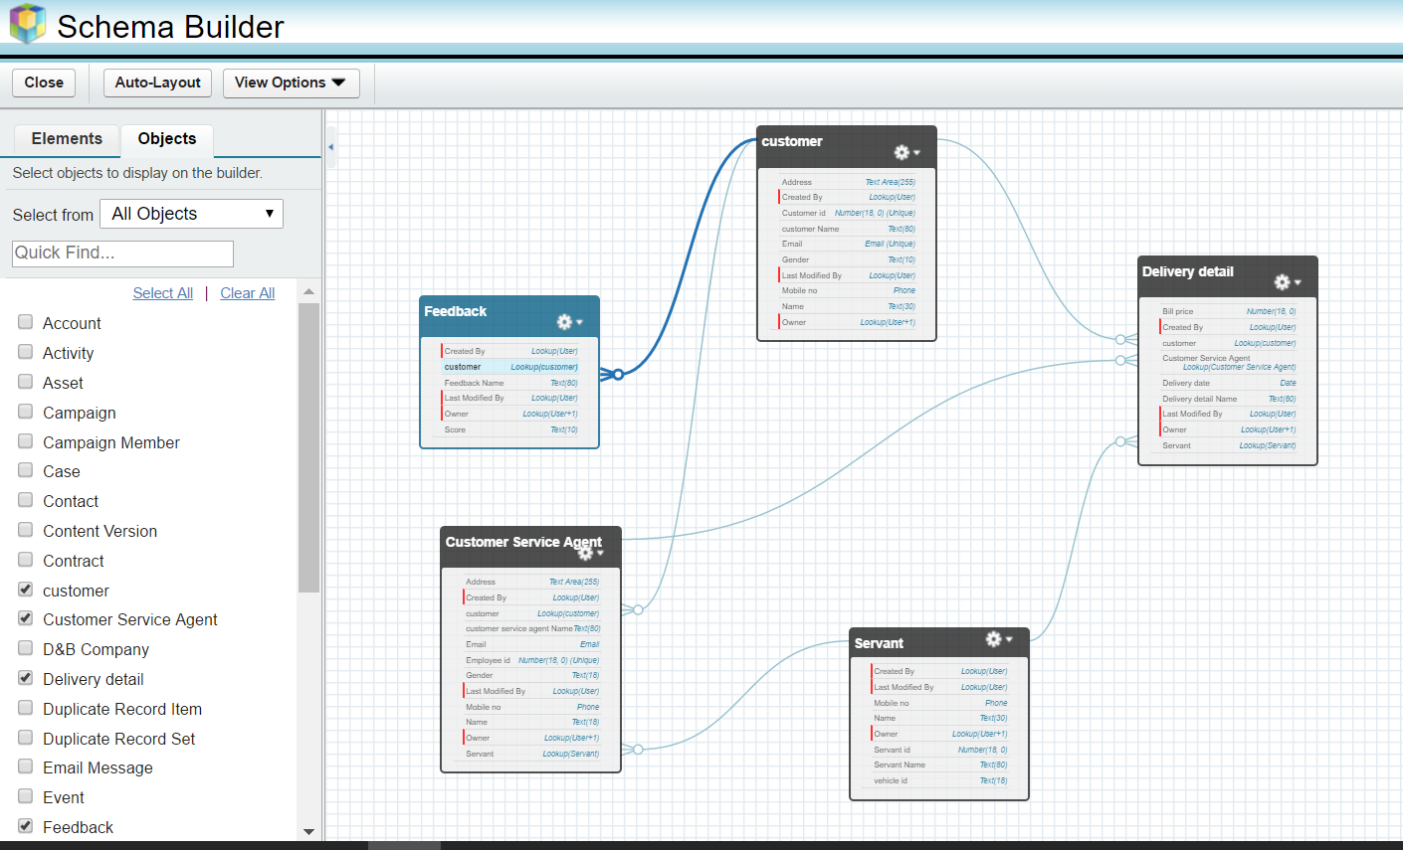

The lookups are used to link one object to another object which is shown in above screenshot. The relations between objects are done with lookups.

3.Integration and User interface:
By using Web to case option in build section, I created a web page for customers where customers can order through online. When customers request for an order, it will create a new case in salesforce where customer service agent will look at the case and initiates servant to deliver the order.

Work Flow Rules:
The customer web from has given below where it contains necessary fields which had to be filled by customer.
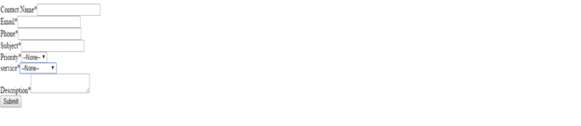
Whenever customer enters the details it will create a new case in salesforce and an email will be sent to customer regarding the case no and details.
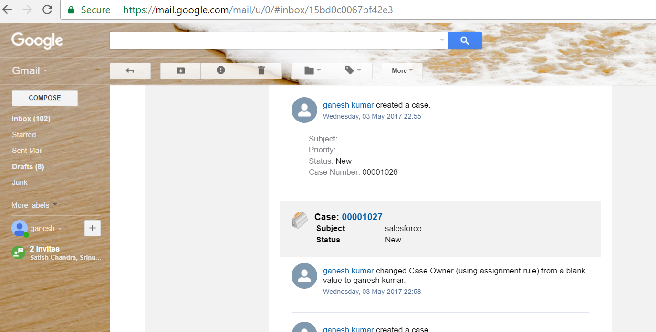
The above web page which is created by using html generator in salesforce. It will help in capturing the case information from website and that data will be shown in cases tab
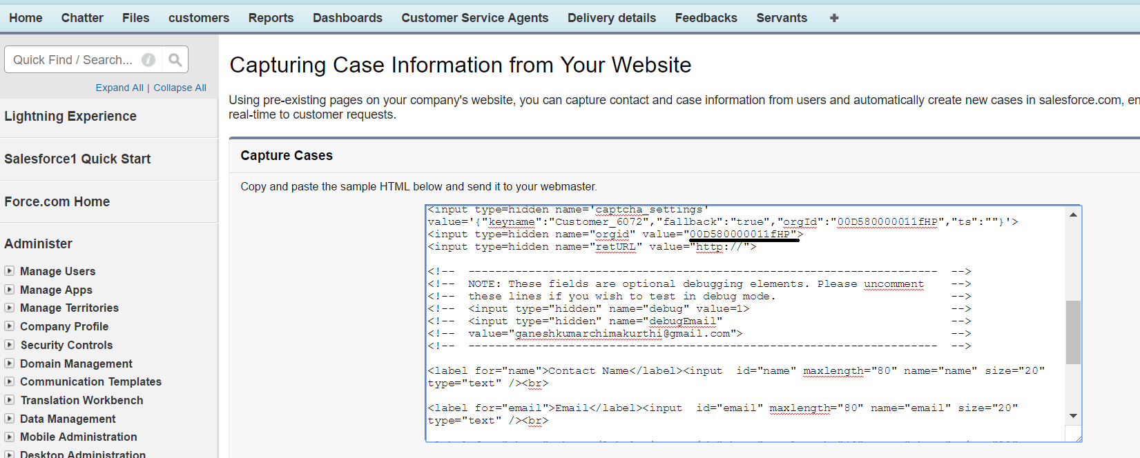

The following screenshot shows the new case which has been created. Whenever customer orders in website, the new case will be created like this in cases tab. Customer service agent will receives those cases and process his orders.

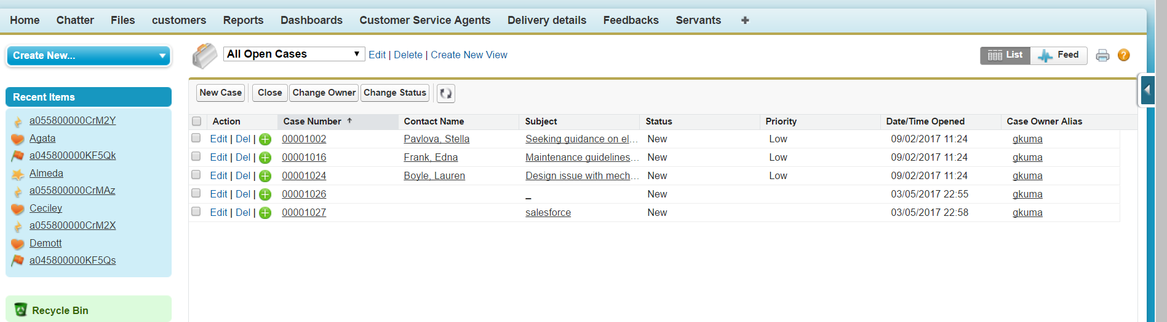

4.Reports and Dashboards:
Reports and dashboards are given below which helps in analyzing the business. 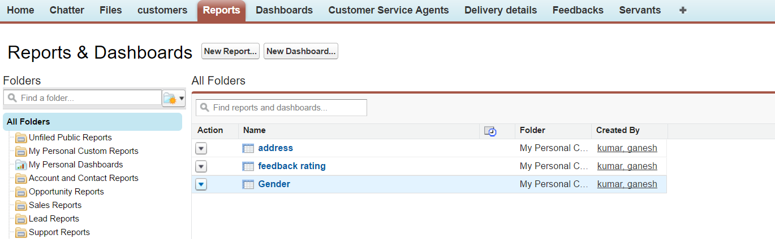

Reports:
Reports are created for the by clicking New Report under Reports tab and by selecting required objects.
Customer Reports:
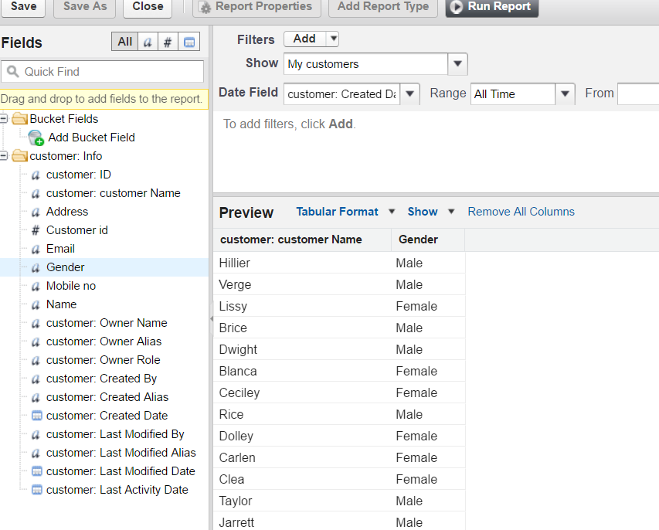

Feedback report:
It contains customer name and score.
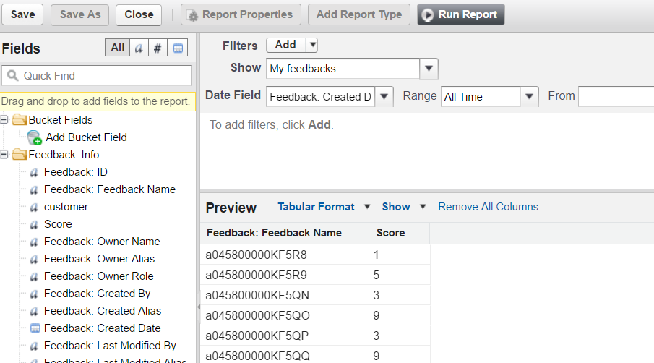

Address report:
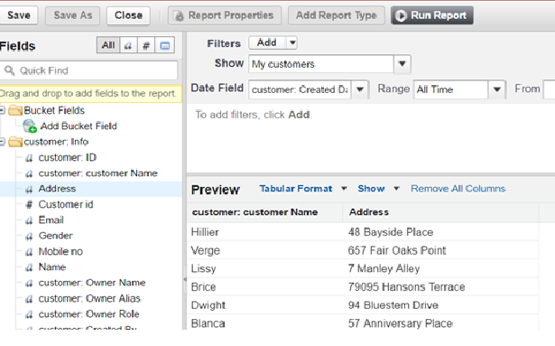
It contains Customer name and address of customer

Dashboards:
Feedback rating:
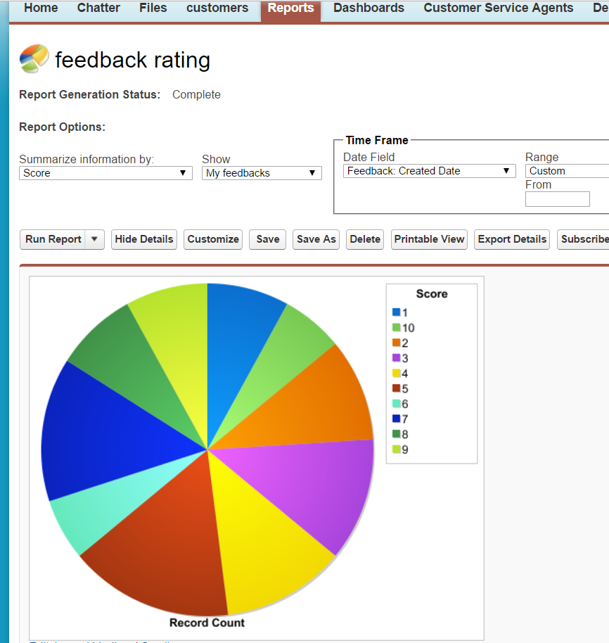
From the report generation, we can say that most of customers are giving scores between 4 and 8. It says that there are most of the sectors has to be developed.

Gender:
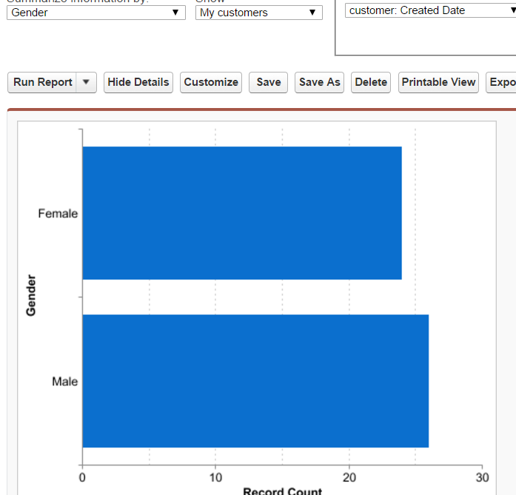
It says that Male and females are almost same in number those who are visiting our organization. But males are bit more comparatively to females.
Address Dashboard:
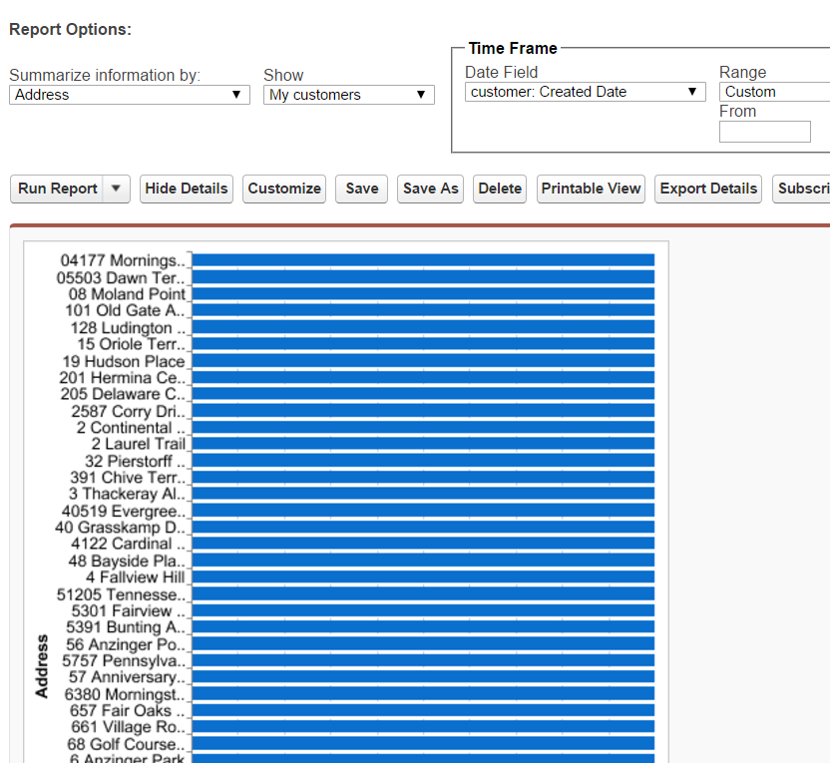
It says about different customers coming from different addresses. From this, we can analyze which area customers are mostly likely to visit our organization.
5.Building Datasets:
I created dummy dataset by using website www.mockaroo.com where datasets are created according to object fields. Finally, the datasets were loaded into salesforce by using Import custom objects in Data present in Quick Links.
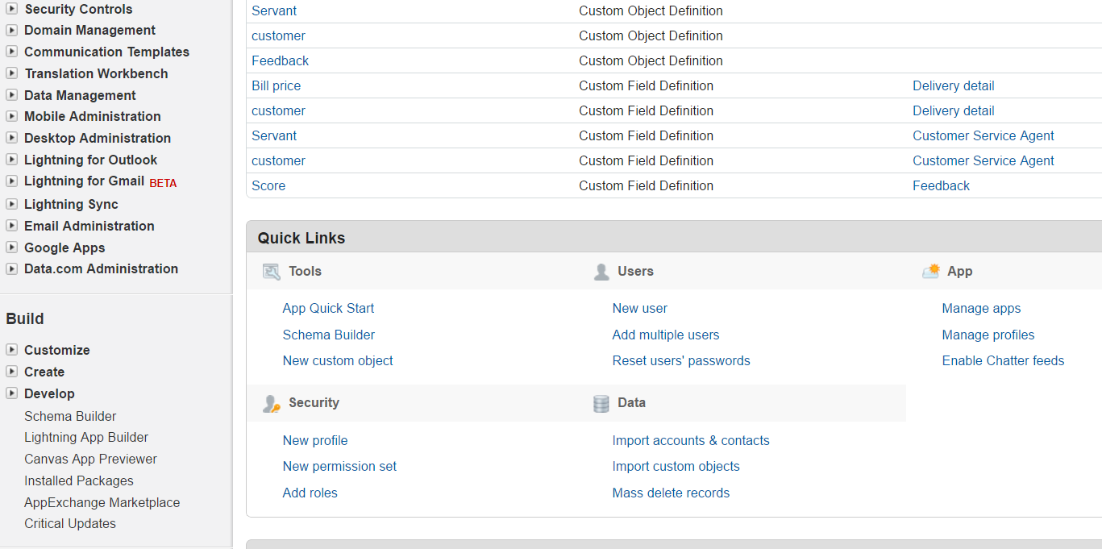
6.Steps while building a system:
To create objects in salesforce, click the setup and go to objects under the build option and click on create. It will create new objects. Similarly, the following screenshot shows list of custom objects.

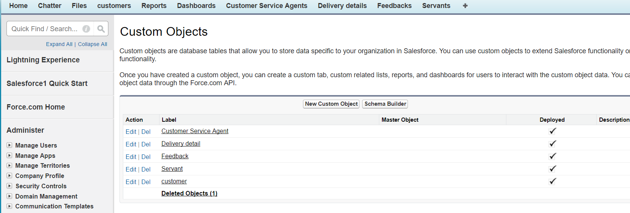

Below screenshot shows the custom tabs of objects. It has been shown by selecting Tab in create option.

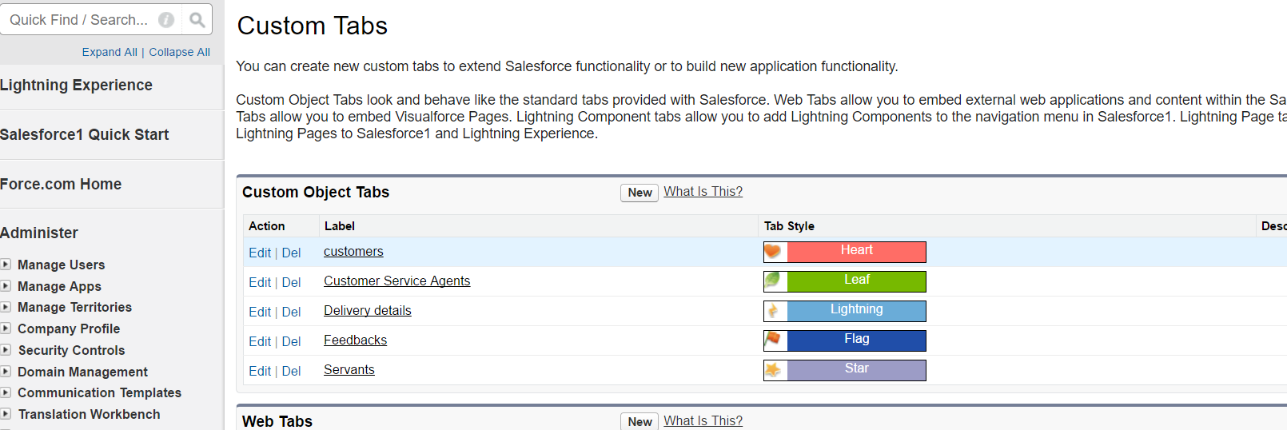

Now the objects with their respective fields are shown below. The relationship between different objects are indicated by using lookups between different objects.

Customer service agent tab fields:
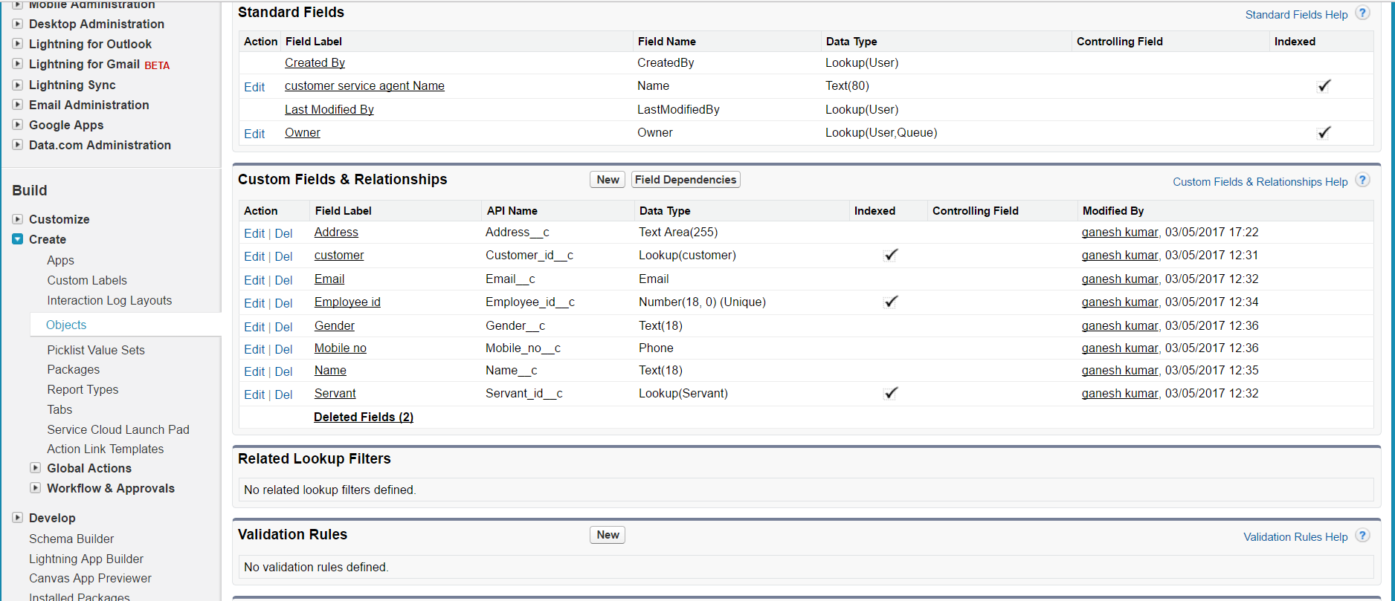

Delivery details tab fields:
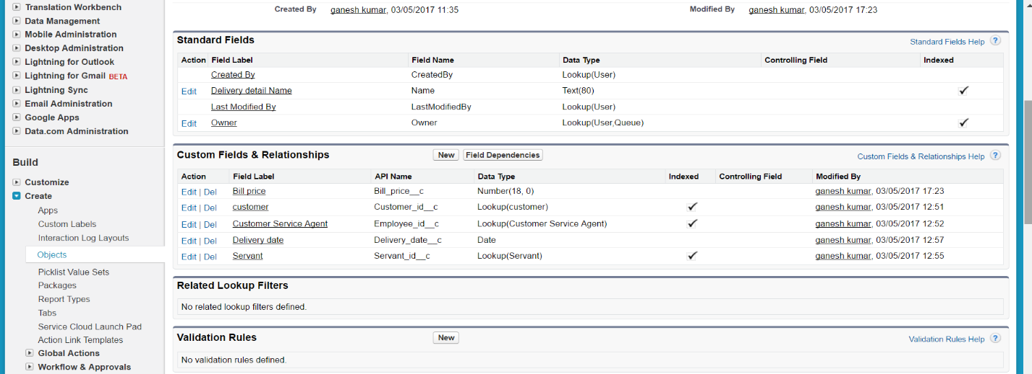

Feedback tab fields:
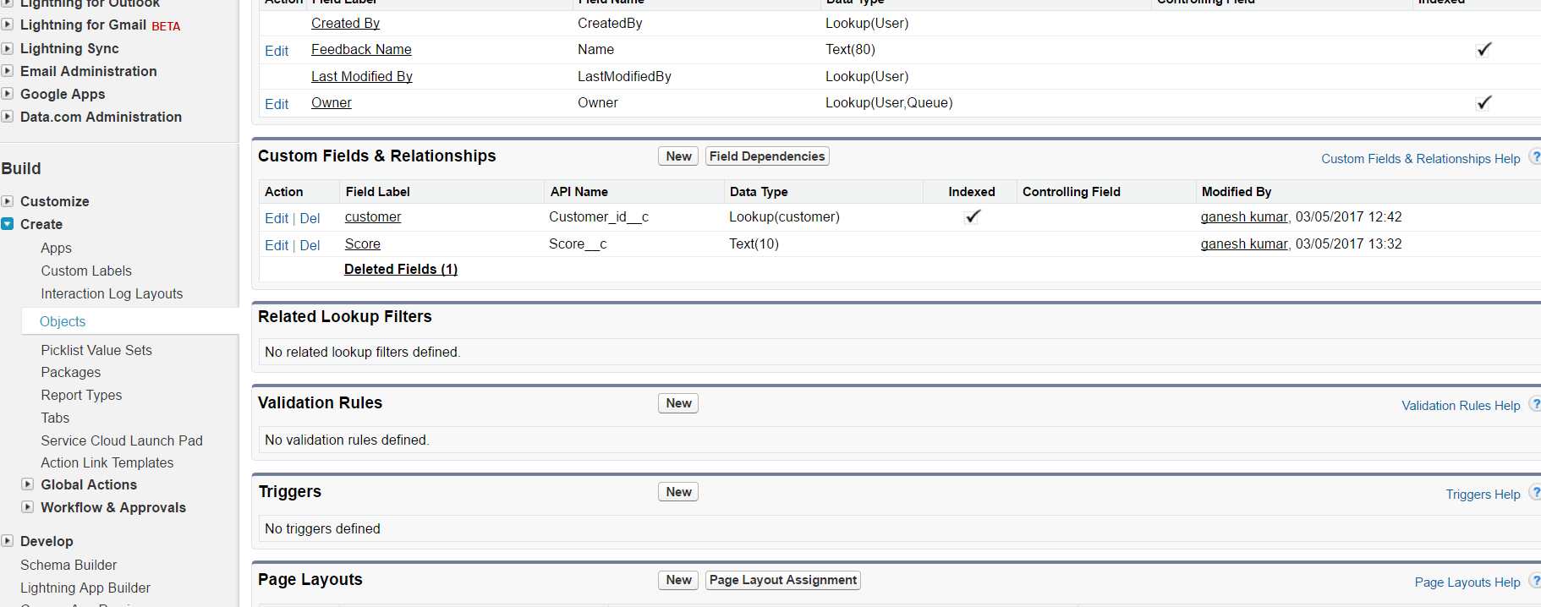
Servant tab fields:
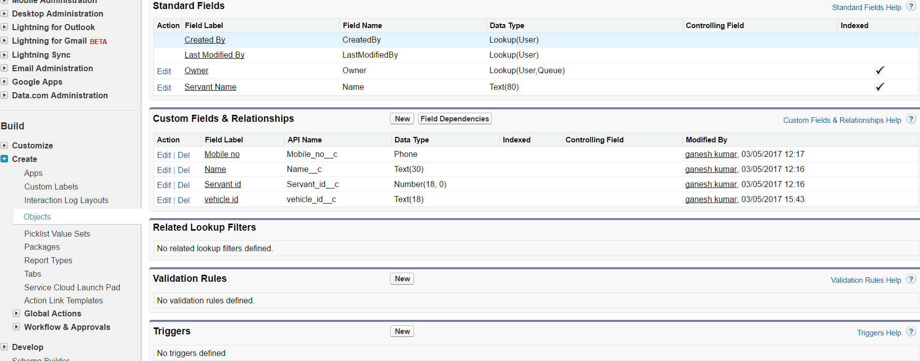
Customer tab fields:
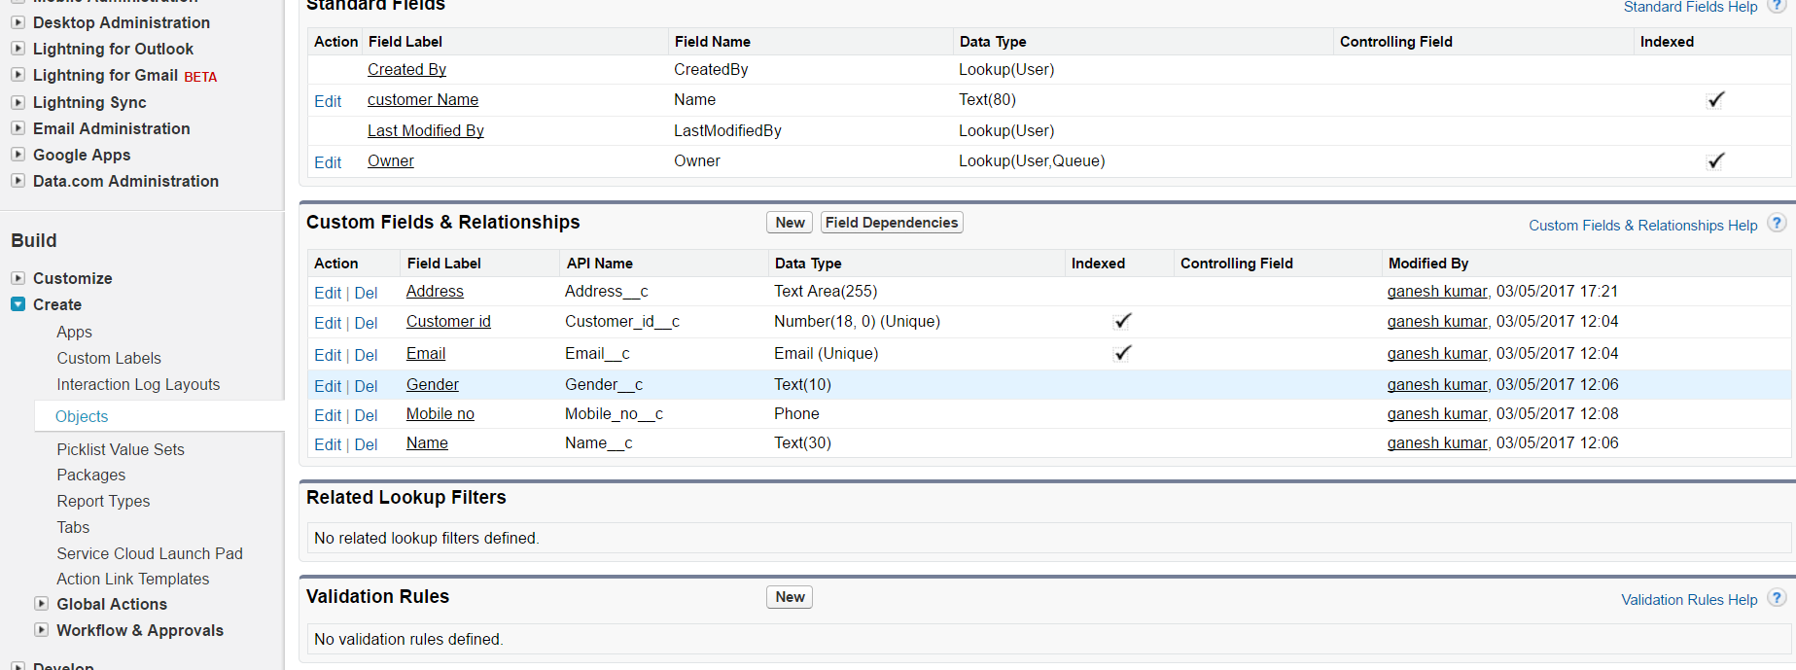
Screenshots after data is loaded in each object are given below,
Data loaded into Customer:

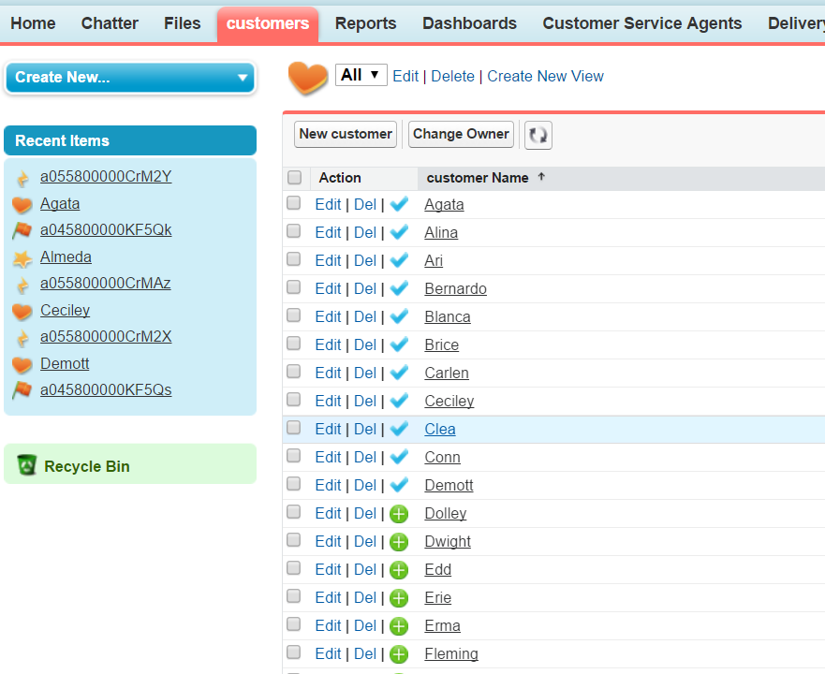

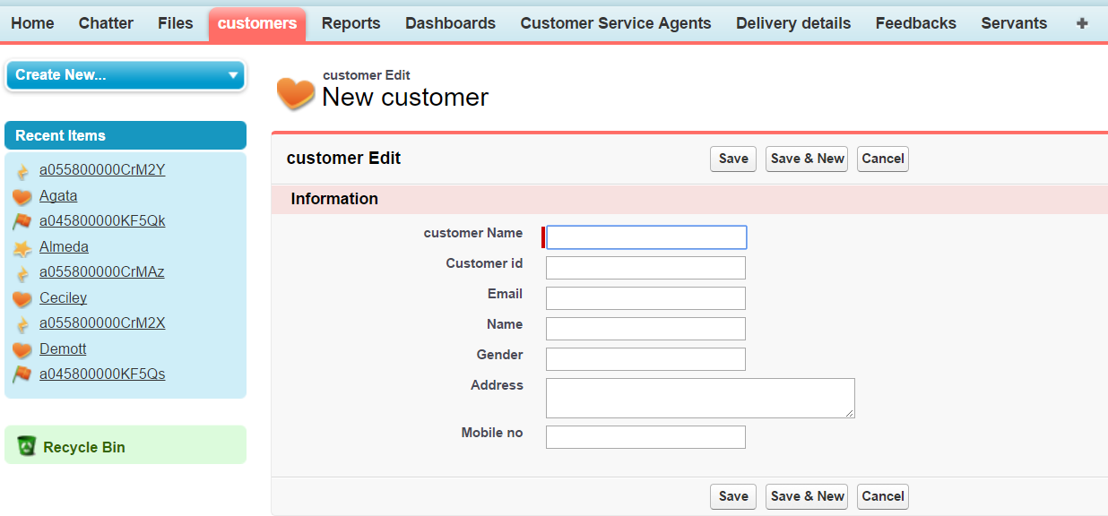

Data loaded into Customer Service Agents:
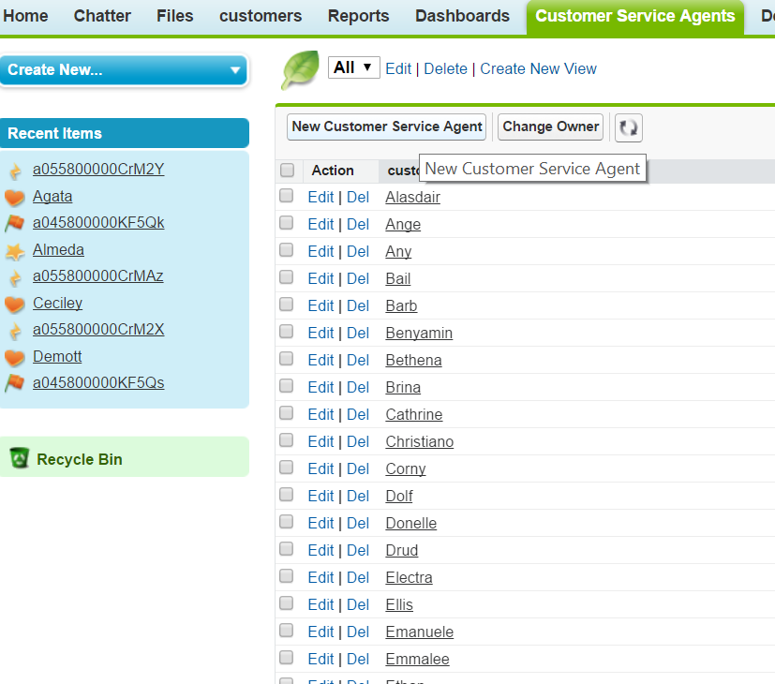

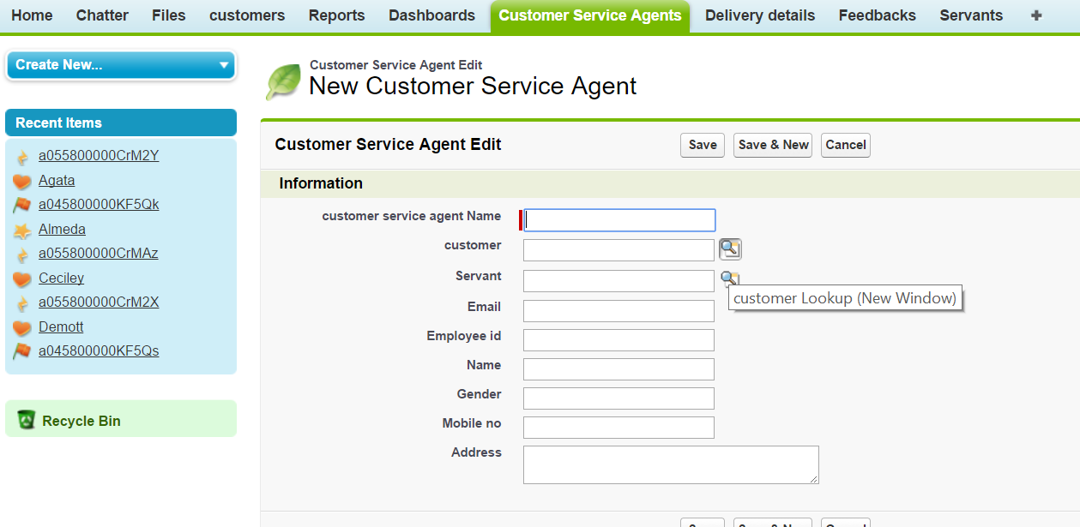
Customer lookup is used to retrieve data from other object.
Data loaded into Delivery details:

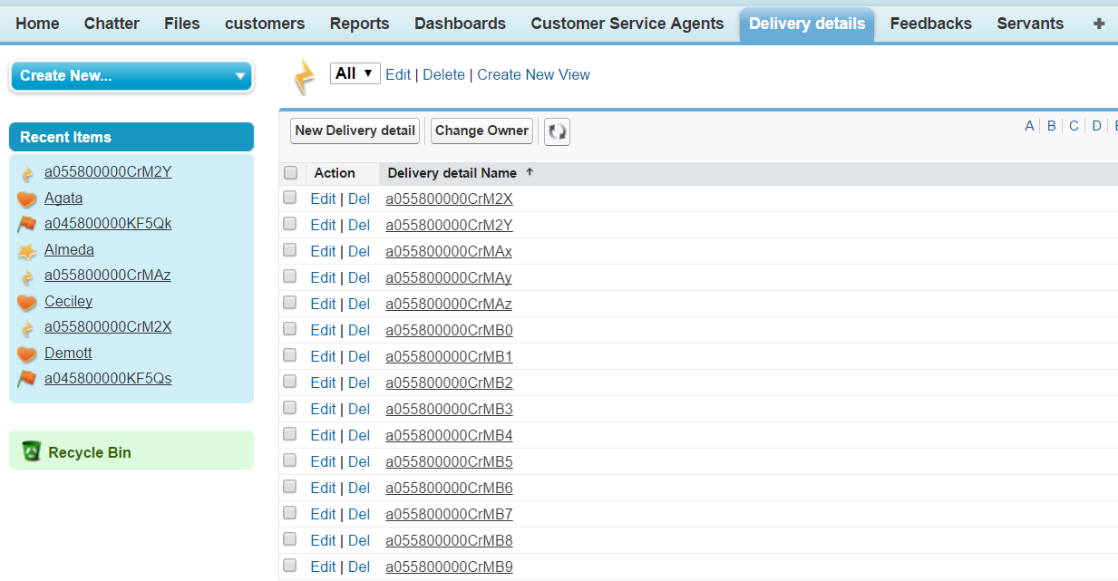

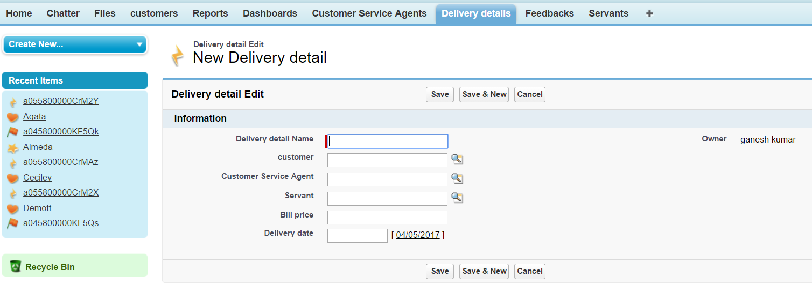

Data loaded into Feedback:

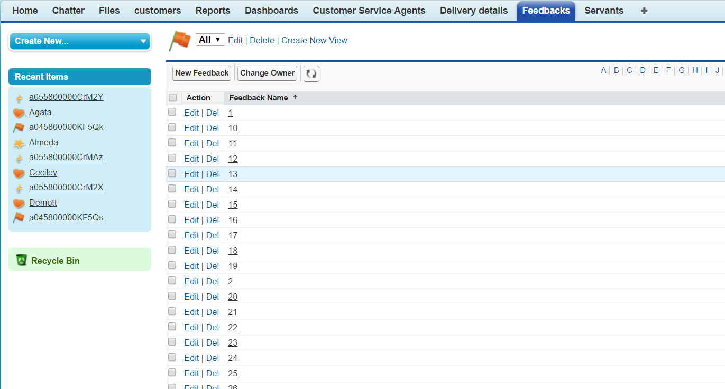

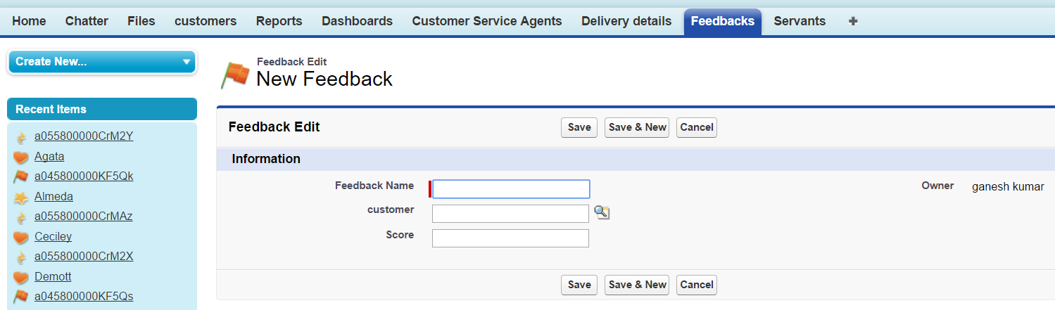

Data loaded into Servant tab:
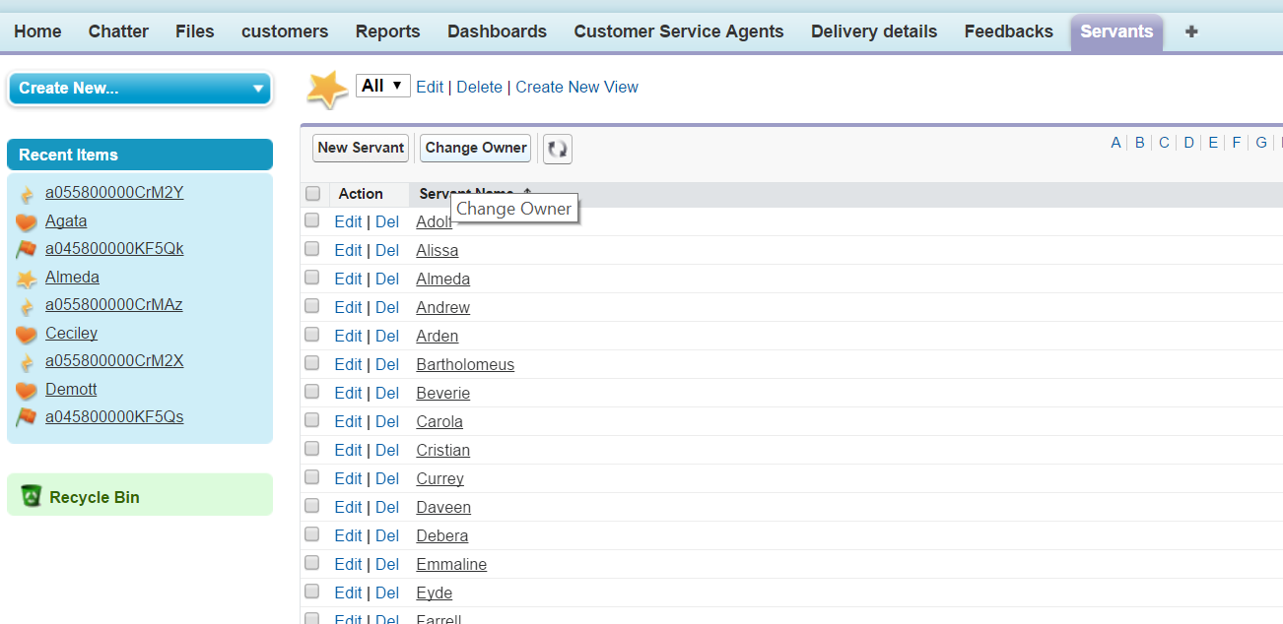

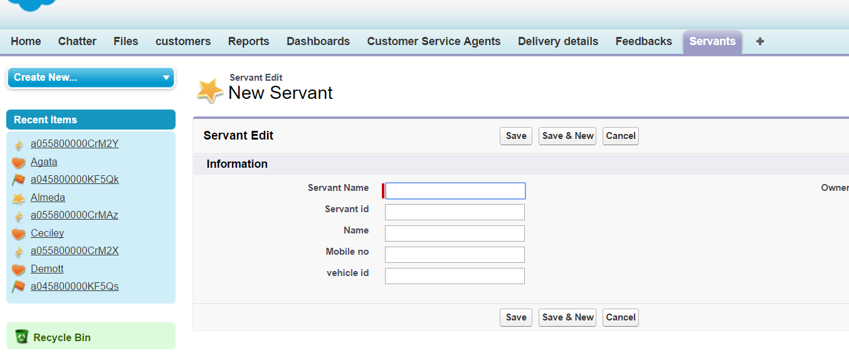

These are the screenshots after loading data in to salesforce.

Process of loading data into salesforce:
The below screenshots shows how data is loaded in to objects. At first I am retrieving data from servant.csv file in to servant object.

Step1:
Selecting Import custom objects in Data in Quick links.
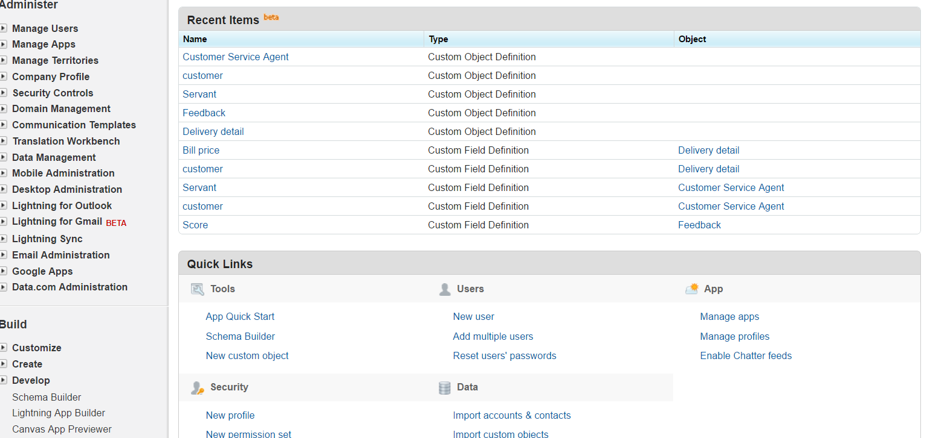

Step 2:
Selecting launch wizard
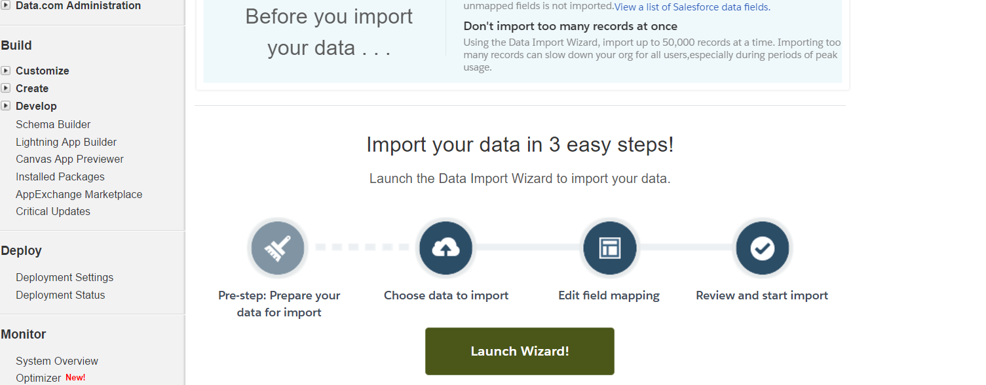
Step 3:
Selecting custom objects and selecting the particular CSV file.

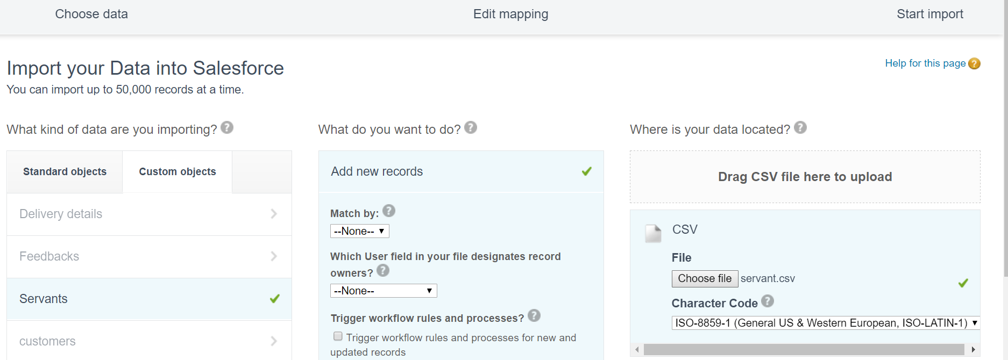

Step 4:
Columns in Objects are mapped into columns in CSV file.
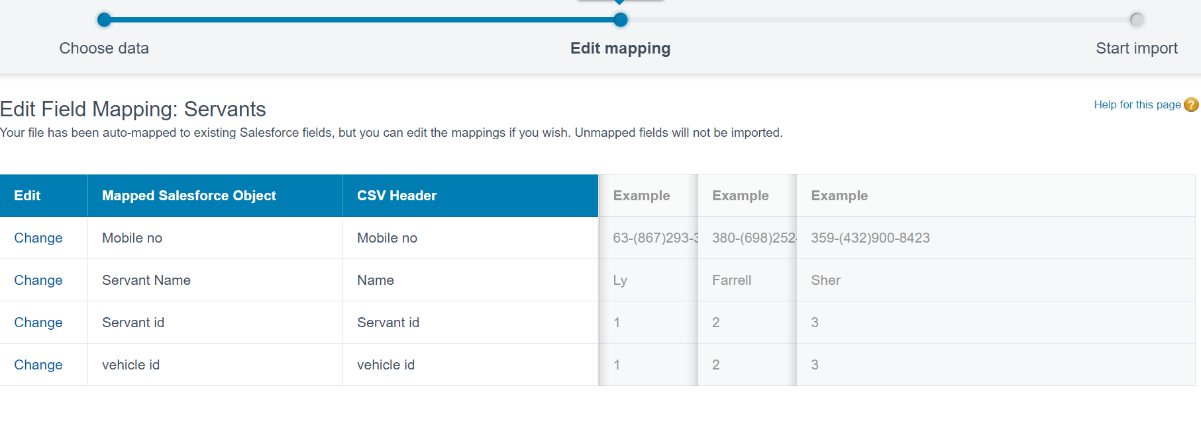

Step 5:
After mapping, data is loaded in salesforce which is shown below
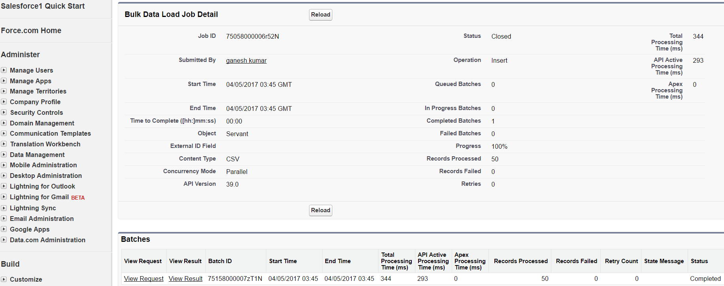

7. How system is used:
- Lots of data can be stored in structured format.
- Analyzing of organization can be done by using multiple reports and dashboards.
- Different tools are available to organization in salesforce which helps to increase expansion of business.
- Using salesforce, it is easy to serve the customer in all aspects.
- Salesforce is combination of all entities so that everyone can communicate with each other.
- Automatic Emails are helpful to customer in tracking the order which is done by salesforce.

8. Benefits:
- Inviting New customers
- Updates of data can be done easily.
- Growth of organization
- Ease of use
- Fast in service
- Monitoring of each task by Customer Service Agent

Conclusion:
Salesforce implementation in business is highly acceptable due to its advantages to customers and organization.

